

**Training/How-To Guide**

**Colorado Convention Center Digital Display Management**

**March 11, 2020**

1

Table of Contents

Introduction 3

Getting Started 3

Logging In 3

Selecting Your Event 4

Modifying 5

Template Themes 5

Mass Uploading Event Information 7

Adding a Single Event / Modifying Existing Event 10

Previewing Events 12

# Introduction

The following user guide contains information regarding the digital display management tool layout as well as step-by-step instructions on how to update and manage the available meeting room signs.

# Getting Started

**LOGGING IN**

The following link will direct the user to the login screen for the Colorado Convention Center Digital Display Management website

<https://cccddm.com/>

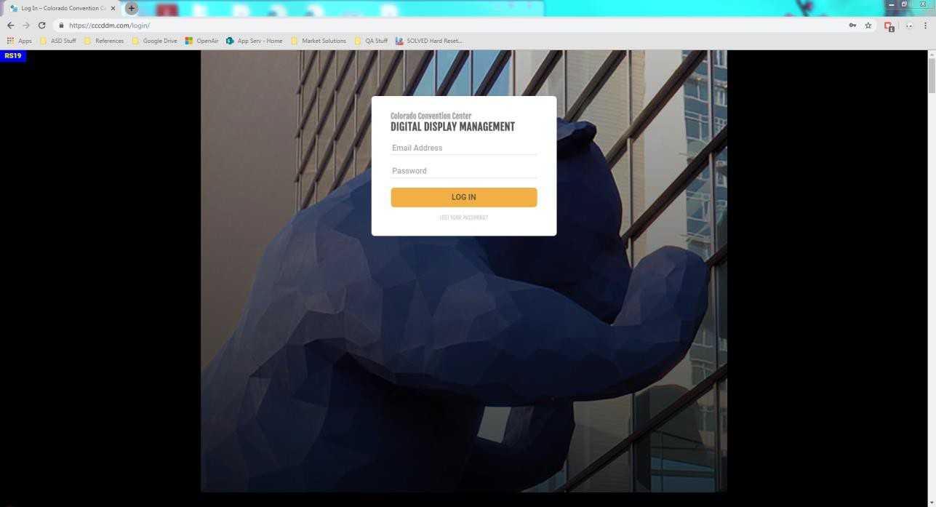

Once the user has landed on the website above, they will need to input their user credentials that have been provided.

**SELECTING YOUR EVENT**

After logging in, the user will be prompted to select an event in order to proceed.

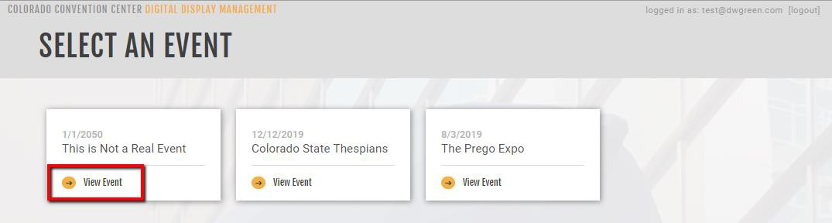

Once an event has been selected, the following actions will be available:

* Edit Template Themes
* Import a .XLSX or .CSV file with all your event information
* Add a Single Event
* Modify Existing Events
* 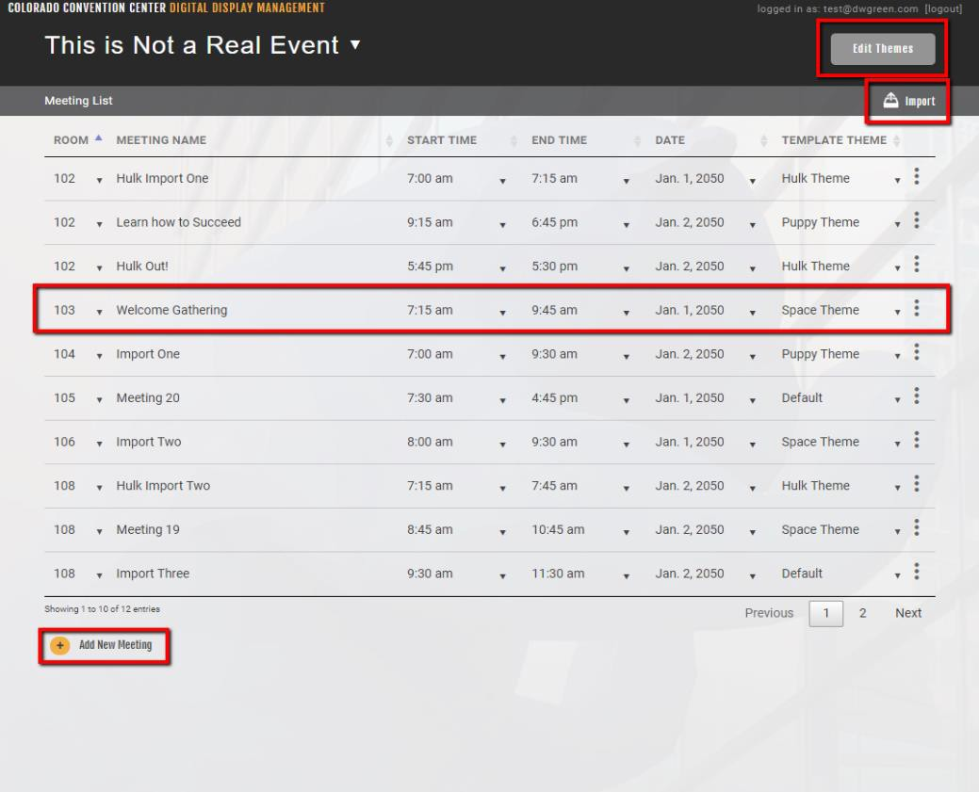Preview Event Template

# Modifying

**TEMPLATE THEMES**

Themes determine the color and creative outline for the available meeting room signs. To create a new theme or edit an existing theme, the *Edit Themes* button must be selected.

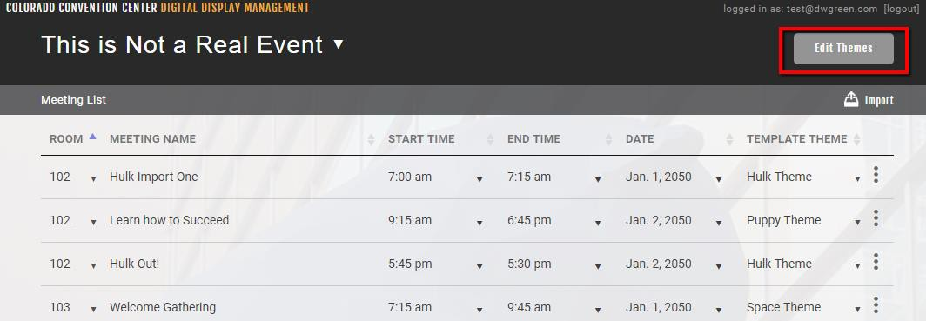

Once the themes landing page has been reached, options for each existing theme can be accessed by hovering over the desired theme image. The options include Preview, Edit, and Apply to All. Preview allows the user to quickly preview the outline of the theme on all four template options. Edit allows the user to edit the sign. Apply to All allows the user to apply the theme to all available meetings.

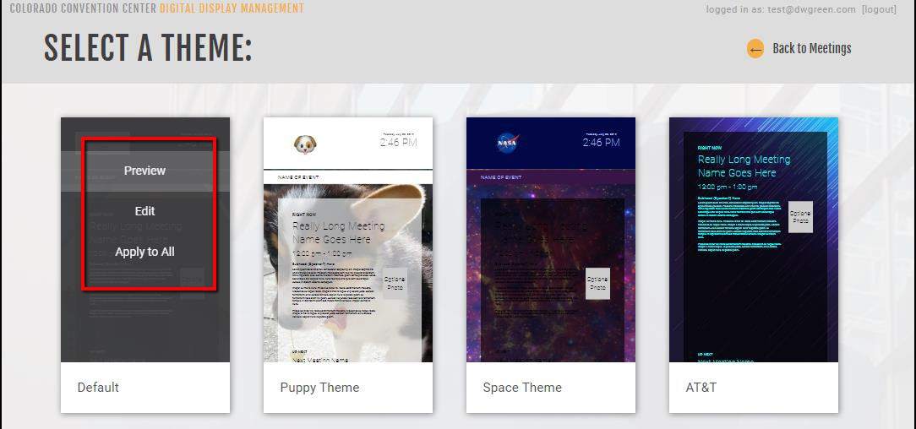

In addition, the user has the ability to add a new theme. This functionality is accessible via the *Add New Theme* button below the existing themes.

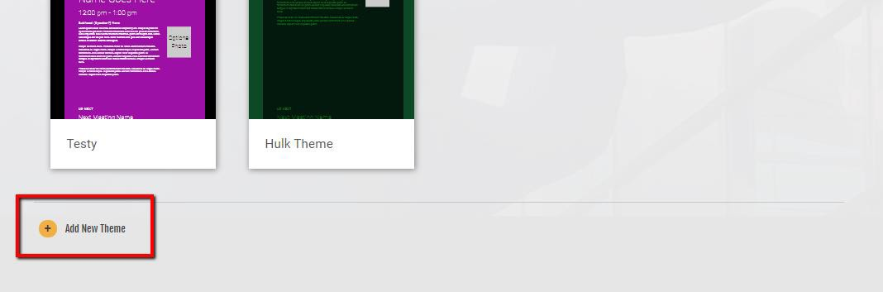

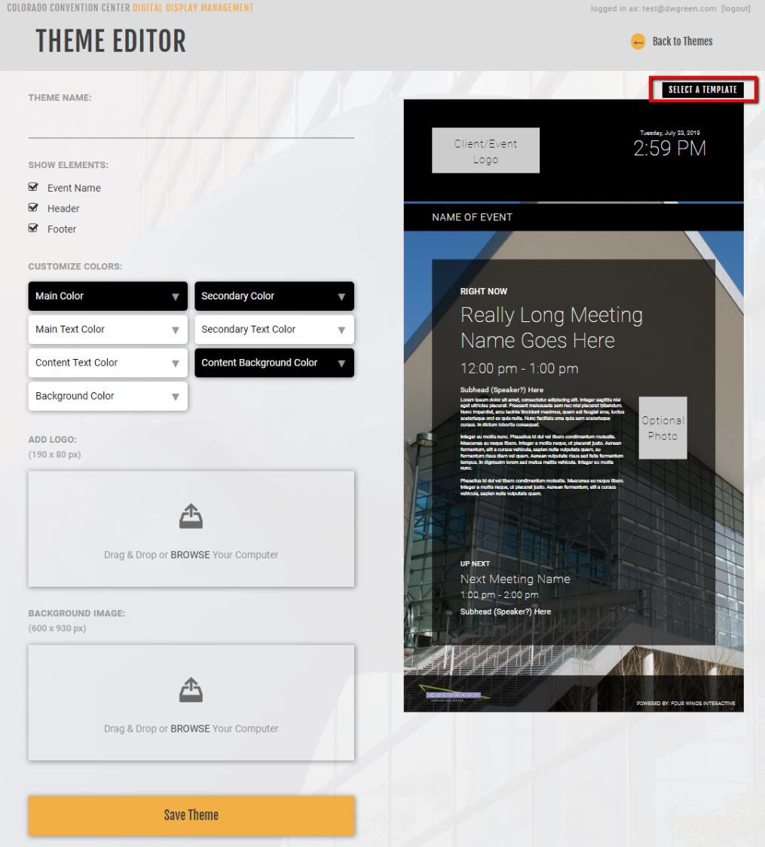Within the Theme Editor, there are four template layout options to choose from using the *SELECT A TEMPLATE* button. After the desired

template has been selected; the available customizable fields will generate on the left side of the screen. Once the fields have been adjusted as necessary, the *Save Theme* button can be selected at the bottom of the screen.

**IMPORTING A .XSLX or .CSV FILE WITH MULTIPLE EVENTS**

From the event landing page, the option to mass upload event information is available through the *Import* button.

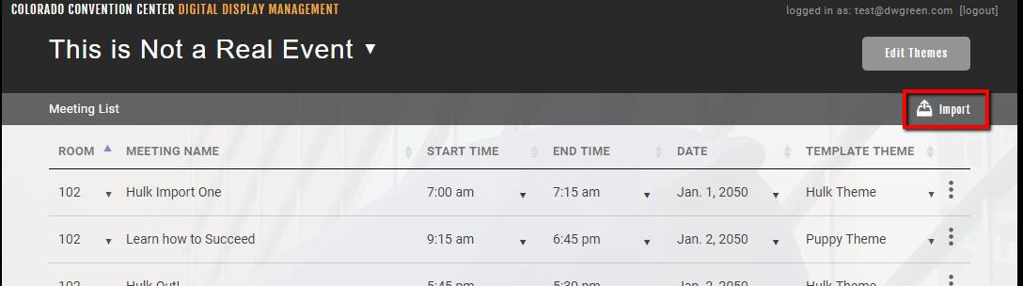

A pop-up window will display and a sample .XLSX file can be downloaded to fill out or use as a model to adjust an existing set of data.

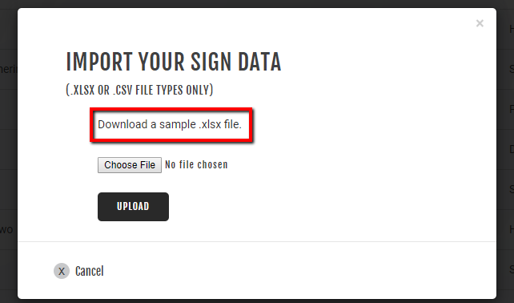

Inside the Excel file multiple events can be added. Use the dropdown menus to fill out the following columns: ***room, date, start and end*.**

*Note: You will only be able to upload events to the specific rooms and dates that you have agreed upon with the Colorado Convention Center – all other events added to the file will be ignored.*

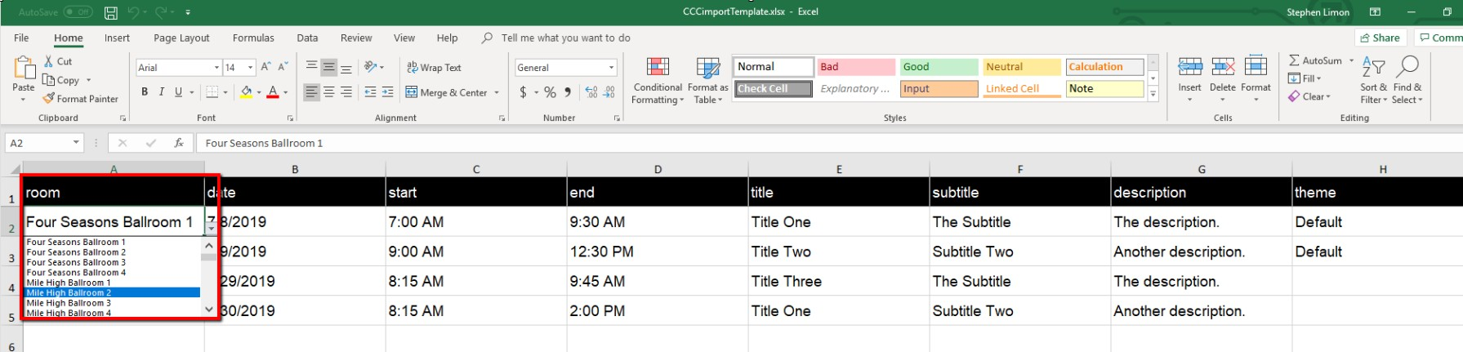

When filling out the ***theme*** column, use the name of the theme column as the name was entered in the Theme Editor.

The themes can be previewed in the Theme Editor. Examples of the default layouts are available below.

Template 1 Template 2

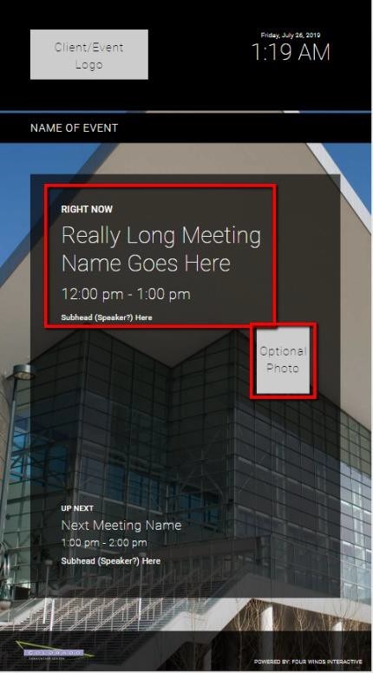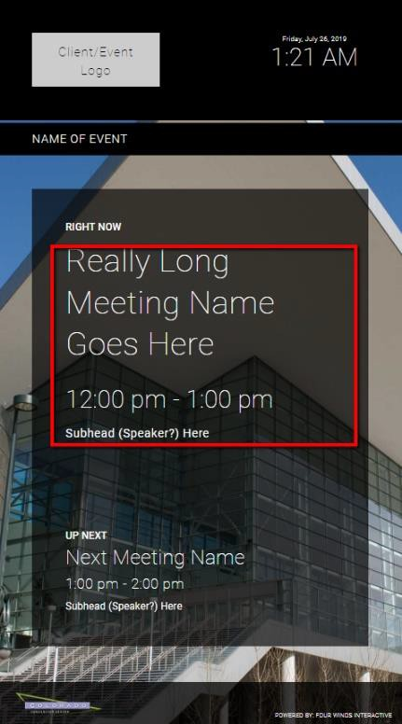

Template 3 Template 4

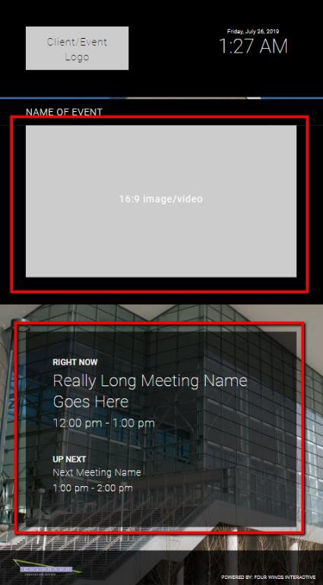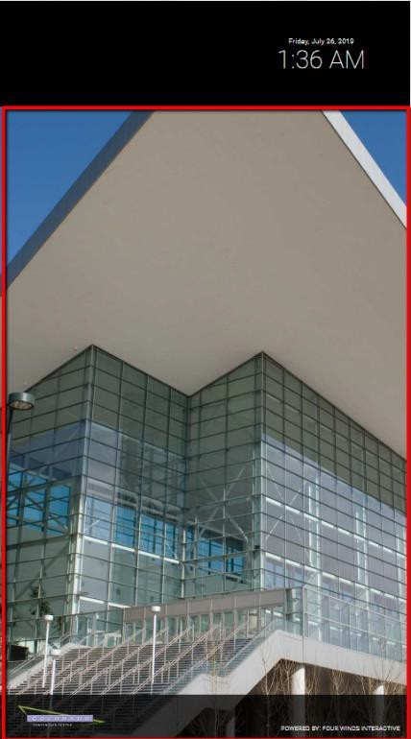

Once all relevant rows of data have been modified in the Excel file, proceed back to the Import option in the browser.



Within the Import pop-up window, select the *Choose File* button. Navigate to the Excel file with the meeting data using the computer’s file explorer. Once the Excel file has been chosen, select the *Upload* button.

When the upload is complete a confirmation message will appear in a pop-up window:

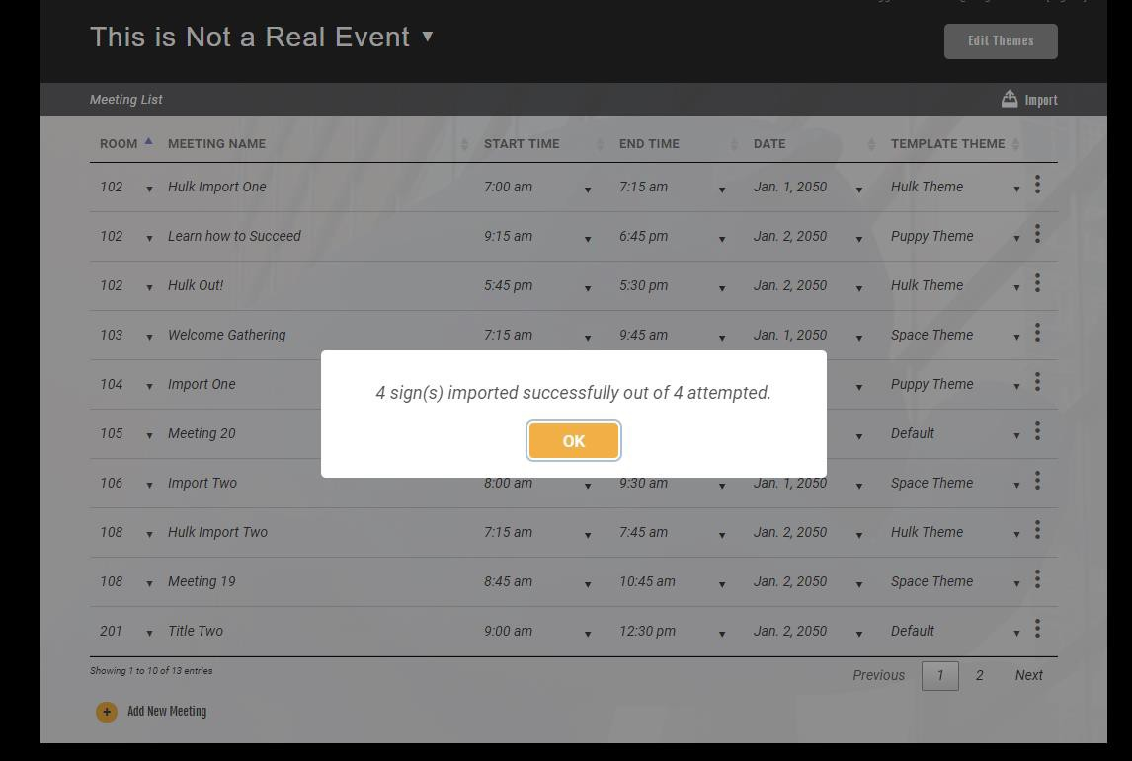

**ADDING A SIGNLE MEETING / MODIFYING EXISTING MEETINGS**

A single meeting can be added from the event landing page. At the bottom of the existing meetings list, select the *Add New Meeting* button. After being redirected to the Enter Meeting Details page, the user will have the ability to edit meeting details and select the template that will apply to the meeting.

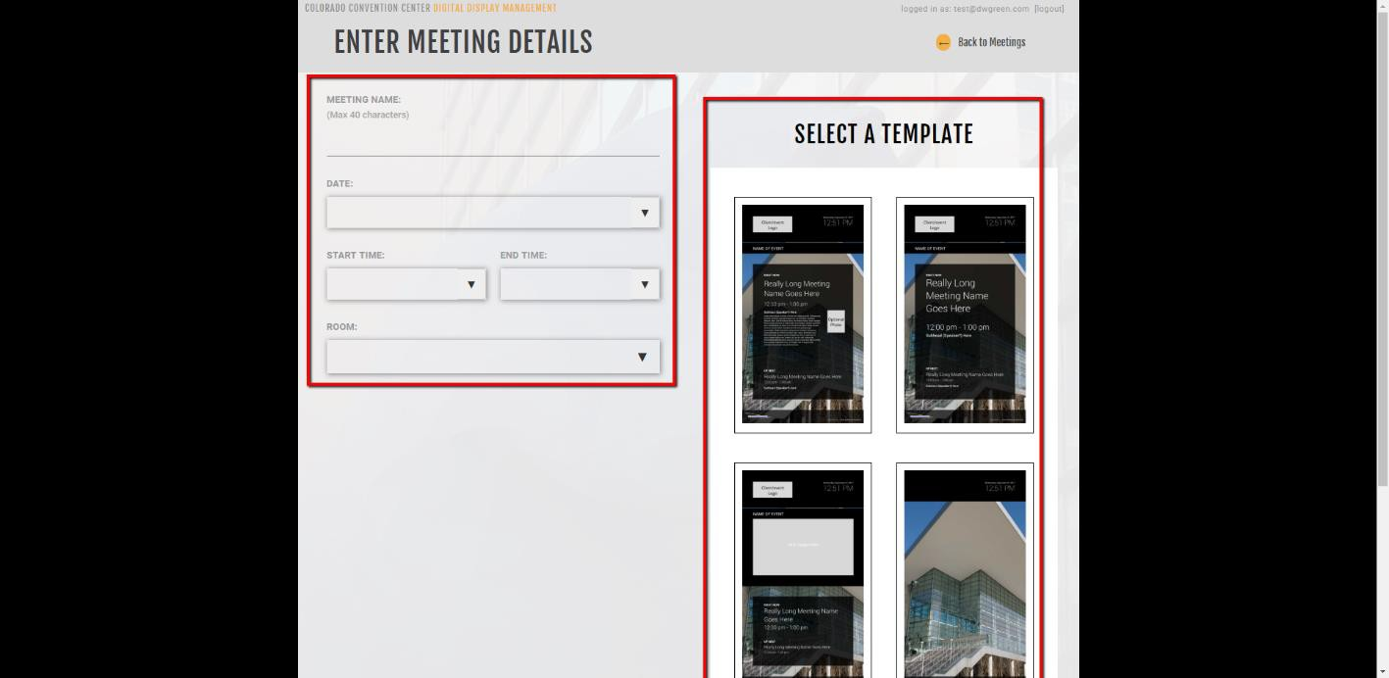

After filling out the required fields, select the *Save Meeting* button at the bottom of the screen to submit the meeting details.

Once the meeting is saved, the browser will be redirected back to the event landing page. The meeting will now be available from the existing list. There are additional actions available from the event page that will allow editing of the various relevant fields.

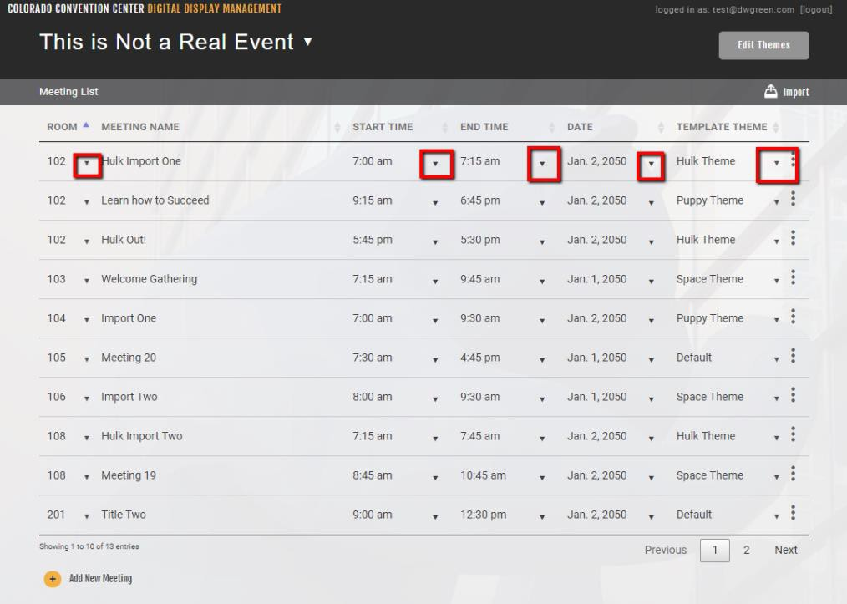

**PREVIEWNG A MEETING**

The layout of a meeting can be previewed from the event landing page using the extended menu button for specific meetings. Once the extended menu button has been selected, a drop-down menu will appear with the options Edit, Preview, and Delete. Select the Preview option and a pop-up with an image of the meeting will display.

